St. Joseph Rosary Altar Society
Annual Communion Brunch

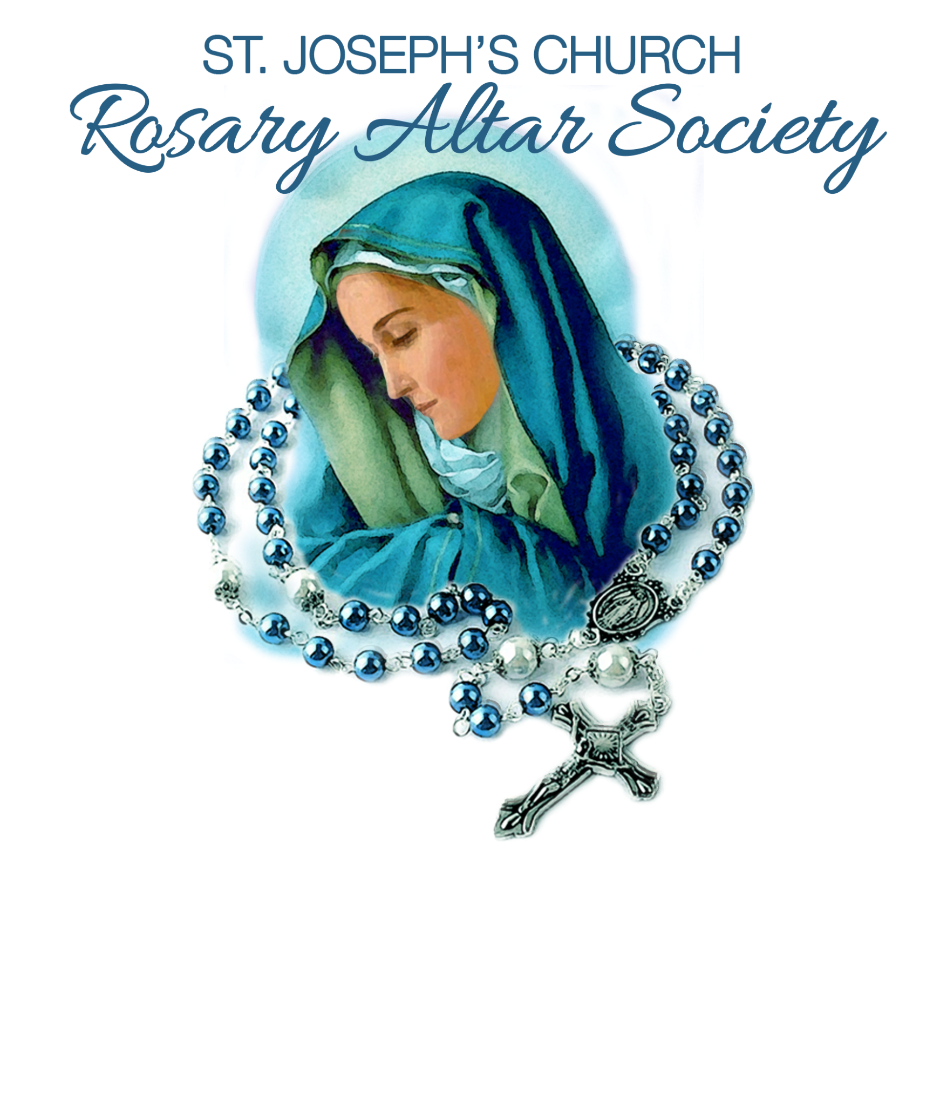
Date: Sunday, October 19, 2025
Mass: 10:30am
Brunch: Immediately following mass
11:45am - 3:00pm

Location: Donovan Catholic Cafeteria
711 Hooper Avenue
TR 08753

Speaker: Deacon Ed Woram
Cost: $35.00

Please respond by October 13, 2025. No tickets will be sold at the door.
Call Helen DiPaola 732-232-4028

*************************************************************************************
Make checks payable to: St. Joseph Rosary Altar Society
Mail to: Helen DiPaola 325 Van Pelt Place, Bayville NJ 08721

NAME: ____________________________________________________

ADDRESS: _________________________________________________
EMAIL: _____________________________________________________
CELL #: ___________________AMOUNT ENCLOSED:______________

